**ABSTRACT**

The Online Bike Rental System is a web-based application designed to provide an efficient and convenient platform for customers to rent Bikes from a fleet of vehicles available online. This project aims to streamline the Bike rental process by eliminating the need for manual paperwork and enabling users to make reservations, manage bookings, and access important information with ease.

The system provides a user-friendly interface that allows customers to browse through a wide range of available Bikes, filter them based on specific criteria such as location, Bike type, and rental duration, and make bookings accordingly. It incorporates secure and ensuring a seamless and trustworthy experience for users.

Administrators have access to a dedicated dashboard where they can manage the fleet of vehicles, update their availability and pricing, and handle customer inquiries. The system also includes features such as customer reviews and ratings, allowing users to make informed decisions while selecting a Bike.

Overall, the Online Bike Rental System simplifies the Bike rental process, saving time and effort for both customers and administrators. By harnessing the power of digital technology, this system offers a secure, efficient, and user-friendly platform that revolutionises the way Bike rental services are accessed and utilized in the modern era.

**TABLE OF CONTENTS**

**PAGE NO.**

**1-3**

**4-16**

**17-18**

**19-20**

**21-23**

**24-34**

**35-39**

**40-43**

**44-45**

**46-47**

**48-49**

**50-51**

**TITLE**

**CHAPTER 1: INTRODUCTION**

**CHAPTER 2: REQUIREMENT ANALYSIS**

**CHAPTER 3: MODULE**

**CHAPTER 4: ER- DIAGRAM**

**CHAPTER 5: DATABASE DESIGN**

**CHAPTER 6: CODING**

**CHAPTER 7: TESTING**

**CHAPTER 8: SCREENSHOTS**

**CHAPTER 9: ANALYSIS AND DESIGN**

**CHAPTER 10: CONCLUSION**

**CHAPTER 11: FUTURE ENHANCEENT**

**CHAPTER 12: BIBLIOGRAPHY**

**CHAPTER 1**

**INTRODUCTION**

**INTRODUCTION**

Nowadays, there is Online Car Rental which gives much benefit to users. A rental service is a service where customers arrive to request the hire of a rental unit. It is more convenient than carrying the cost of owning and maintaining the unit. A car rental company is a company that rents automobiles for a short period of time for a fee for a few hours or a few days or a week.

* **Objective:**

The objective of the project is to automate vehicle rental and reservation so that the customers do not need to call and spend unnecessary time to reserve a vehicle:

1. To transform the manual process of hiring a car to a computerized system.
2. To validate the Rental car system using a user satisfaction test.
3. To produce the documentation such as Software Requirement Specification (SRS), Software Design Description as system development reference
4. This feature helps optimize fleet management and ensures prompt delivery and pickup of vehicles

* **Methodology / Procedure:**
* For the development of the project the designing of the database was done on PHPMYADMIN, back end was coded in basic PHP and for frontend we used the same basic PHP codes
* Software methodologies are concerned with the process of creating software – not so much the technical side but the organizational aspects. Several software development approaches have been used since the origin of information technology
* **Scope:**

It's important to conduct thorough market research and feasibility studies in your target location to understand the demand, competition, and potential challenges. Keep in mind that the market may have evolved beyond this scope by the current date of July 2023, so it's best to verify the latest trends and developments in the bike rental industry before proceeding with your venture.

* **Existing System:**
* Content Management Systems (CMS): These systems allow for the creation and management of website content without the need for extensive coding knowledge. Popular CMS include WordPress, Drupal, and Joomla
* Server-side scripting languages: These languages allow for the creation of dynamic websites by generating HTML on the server-side, based on user requests. Examples of server-side scripting languages include PHP, Python, and Ruby.
* JavaScript frameworks: These are libraries of pre-written code that can be used to build complex dynamic websites. Examples of JavaScript frameworks include Angular, React.
* **Proposed System:**

Online bike rental system would typically consist of several components and functionalities. Here's an outline of the key features and components that could be included in such a system:

* User Registration and Authentication:
  + Allow users to register and create accounts using their email or social media accounts.
  + Implement a secure authentication mechanism to protect user data.
* Bike Listing and Inventory Management:
  + Provide a user-friendly interface to list available bikes for rent.
  + Include bike details such as model, type, size, features, and rental rates.
  + Implement an inventory management system to track the availability of bikes in real-time.
* Search and Filter Options:
  + Enable users to search for available bikes based on location, date, time, and bike specifications.
  + Offer filter options to refine search results based on preferences
* Booking and Reservation
  + Allow users to select a bike, choose rental dates, and make reservations.
  + Implement a secure payment gateway to process rental payments.
* Admin Panel:
  + Create an admin panel to manage bike listings, inventory, and user accounts.
  + Enable admins to add or remove bikes, set rental rates, and monitor bookings.

**CHAPTER 2**

**REQUIREMENT ANALYSIS**

**REQUIREMENT ANALYSIS**

* **Problem definition:**

In this section, we define problems. The problem is that, when results are to be declared, lot of money, physical space, man power is required. And there are so many candidates who needs to get their result, but due to medical illness or some emergency they are not able to visit the institute. Another problem is that, it depends on physical presence of the candidates to get their result.

* **Applications requirements:**

1. **Visual Studio Code:**

* ****Visual Studio Code is an integrated development environment made by Microsoft for Windows, Linux and MACOS. Features include support for debugging, syntax highlighting, intelligent code completion, snippets, code refactoring, and embedded Git. Users can change the theme, keyboard shortcuts, preferences, and install extensions that add additional functionality. Microsoft has released most of Visual Studio Code's source code on GitHub under the permissive MIT License, while the releases by Microsoft are proprietary freeware.
* In the Stack Overflow 2021 Developer Survey, Visual Studio Code was ranked the most popular developer environment tool, with 70% of 82,000 respondents reporting that they use it. Visual Studio Code was first announced on April 29, 2015, by Microsoft at the 2015 Build conference. A preview build was released shortly thereafter. On November 18, 2015, the source of Visual Studio Code was released under the MIT License, and made available on GitHub. Extension support was also announced. On April 14, 2016, Visual Studio Code graduated from the public preview stage and was released to the Web.

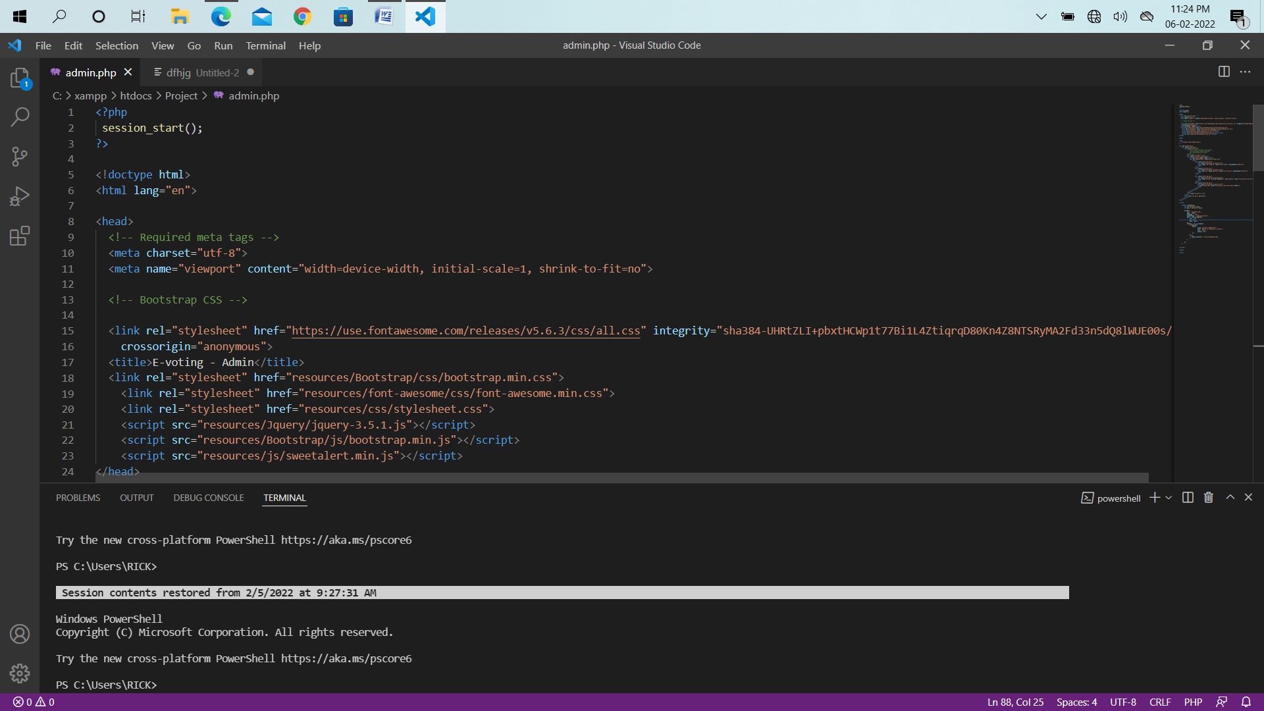

1. **XAMPP:**

* The full form of XAMPP is (X) stands for Cross-platform, (A) Apache server, (M) Maria DB, (P) PHP and (P) Perl. XAMPP is an open source free software developed by Apache friends. XAMPP software package contains Apache distributions for Apache server, Maria DB, PHP, and Perl. And it is basically a local host or a local server. This local server works on your own desktop or laptop computer. You can just install this software on your laptop or desktop and test the clients or your website before uploading it to the remote web server or computer. This XAMPP server software gives you suitable environment for testing MYSQL, PHP, Apache and Perl projects on the local computer.
* The Cross-platform usually means that it can run on any computer with any operating system. Next Maria DB is the most famous database server and it is developed by MYSQL team. PHP usually provides a space for web development. PHP is a server-side scripting language. And the last Perl is a programming language and is used to develop a web application.
* **Main Tools of XAMPP and its Definition:**
* XAMPP contains tools such as Apache, MYSQL, PHP, and Perl. We will see these tools.
* **Apache:**
* Apache server is an open source free software which is initially developed by a group of software developers and now it is maintained by Apache software foundation. Apache HTTP is a remote server (computer) if someone request files, images or documents using their browser they will serve those files to clients using HTTP servers. Mainly hosting companies use this application to create a VPS server and shared hosting for their clients.
* **MYSQL:**

MYSQL is open-source software. It is actually a relational database management system (RDBMS). This SQL stands for Structured Query Language. It is the most popular and best RDBMS used for developing a variety of web-based software applications. With the help of MYSQL, it is possible to organize the information, manage, retrieve and update the data whenever you wish to do.

* **PHP:**

The full form of PHP is Hypertext Preprocessor. It is a server-side scripting language that helps you to create dynamic websites. This language is mainly used to build web-based software applications. It is open-source software and works fine with MYSQL. What actually happens is, the PHP code will be executed on the server and at the browser side its HTML code will be displayed.

* **Programming Technology Requirements:**

**HTML:**

* HTML (Hyper Text Markup Language) is the most basic building¬ block of the Web. It defines the meaning and structure of web content. Other technologies besides HTML are generally used to describe a web page's appearance/presentation (CSS) or functionality/behavior (JavaScript). "Hypertext" refers to links that connect web pages to one¬ another, either within a single website or between websites. Links are a fundamental aspect of the Web. By uploading content to the Internet and linking it to pages created by other people, you become an active participant in the World Wide Web.
* HTML uses "markup" to annotate text, images, and other content for display in a Web browser. HTML markup includes special "elements" such as <head>, <title>, <body>, <header>, <footer>, <article>, <section>, <p>, <div>, <span>, <img>, <aside>, <audio>, <canvas>, <datalist>, <details>, <embed>, <nav>, <output>, <progress>, <video>, <ul>, <ol>, <li> and many others.
* An HTML element is set off from other text in a document by "tags", which consist of the element name surrounded by "<" and ">". The name of an element inside a tag is case insensitive. That is, it can be written in uppercase, lowercase, or a mixture. For example, the <title> tag can be written as <Title>, <TITLE>, or in any other way.

**CSS:**

* Cascading Style Sheets (CSS) is a style sheet language used for describing the presentation of a document written in a markup language such as HTML. CSS is a cornerstone technology of the World Wide Web, alongside HTML and JavaScript.
* CSS is designed to enable the separation of presentation and content, including layout, colors, and fonts. This separation can improve content accessibility, provide more flexibility and control in the specification of presentation characteristics, enable multiple web pages to share formatting by specifying the relevant CSS in a separate .css file which reduces complexity and repetition in the structural content as well as enabling the .css file to be cached to improve the page load speed between the pages that share the file and its formatting.
* Separation of formatting and content also makes it feasible to present the same markup page in different styles for different rendering methods, such as on-screen, in print, by voice (via speech-based browser or screen reader), and on Braille based tactile devices. CSS also has rules for alternate formatting if the content is accessed on a mobile device.
* The name cascading comes from the specified priority scheme to determine which style rule applies if more than one rule matches a particular element. This cascading priority scheme is predictable.
* The CSS specifications are maintained by the World Wide Web Consortium (W3C). Internet media type (MIME type) text/css is registered for use with CSS by RFC 2318 (March 1998). The W3C operates a free CSS validation service for CSS documents. In addition to HTML, other markup languages support the use of CSS including XHTML, plain XML, SVG, and XUL.

**JavaScript:**

* JavaScript often abbreviated as JS, is a programming language that conforms to the ECMAScript specification. JavaScript is high-level, often just-in-time compiled, and multi-paradigm. It has curly bracket syntax, dynamic typing, prototype-based object orientation, and first-class functions.
* Alongside HTML and CSS, JavaScript is one of the core technologies of the World Wide Web. JavaScript enables interactive web pages and is an essential part of web applications. The vast majority of websites use it for client side page behavior and all major web browsers have a dedicated JavaScript engine to execute it.
* As a multi-paradigm language, JavaScript supports event driven, functional, and imperative programming styles. It has application programming interfaces (APIs) for working with text, dates, regular expressions, standard data structures, and the Document Object Model (DOM). However, the language itself does not include any input/output (I/O), such as networking, storage, or graphics facilities, as the host environment (usually a web browser) provides those APIs.
* JavaScript engines were originally used only in web browsers, but they are now embedded in some servers, usually via Node.js. They are also embedded in a variety of applications created with frameworks such as Electron and Cordova.
* Although there are similarities between JavaScript and Java, including language name, syntax, and respective standard libraries, the two languages are distinct and differ greatly in design.

**Bootstrap:**

* Bootstrap is a free and open-source CSS framework directed at responsive, mobile-first front-end web development. It contains CSS- and (optionally) JavaScript-based design templates for typography, forms, buttons, navigation, and other interface components.
* Bootstrap is a web framework that focuses on simplifying the development of informative web pages (as opposed to web apps). The primary purpose of adding it to a web project is to apply Bootstrap's choices of color, size, font and layout to that project. As such, the primary factor is whether the developers in charge find those choices to their liking. Once added to a project, Bootstrap provides basic style definitions for all HTML elements. The result is a uniform appearance for prose, tables and form elements across web browsers. In addition, developers can take advantage of CSS classes defined in Bootstrap to further customize the appearance of their contents. For example, Bootstrap has provisioned for light- and dark-colored tables, page headings, more prominent pull quotes, and text with a highlight.
* Bootstrap also comes with several JavaScript components in the form of jQuery plugins. They provide additional user interface elements such as dialog boxes, tooltips, and Bikeousels. Each Bootstrap component consists of an HTML structure, CSS declarations, and in some cases accompanying JavaScript code. They also extend the functionality of some existing interface elements, including for example an autocomplete function for input fields.
* Example of a webpage using Bootstrap framework rendered in Firefox. The most prominent components of Bootstrap are its layout components, as they affect an entire web page. The basic layout component is called "Container", as every other element in the page is placed in it. Developers can choose between a fixed-width container and a fluid-width container. While the latter always fills the width of the web page, the former uses one of the four predefined fixed widths, depending on the size of the screen showing the page:
* Smaller than 576 pixels
* 576–768 pixels
* 768–992 pixels
* 992–1200 pixels
* Larger than 1200 pixels
* Once a container is in place, other Bootstrap layout components implement a CSS Flexbox layout through defining rows and columns.
* A precompiled version of Bootstrap is available in the form of one CSS file and three JavaScript files that can be readily added to any project. The raw form of Bootstrap, however, enables developers to implement further customization and size optimizations. This raw form is modular, meaning that the developer can remove unneeded components, apply a theme and modify the uncompelled Sass files.

**jQuery:**

* JQuery is a JavaScript library designed to simplify HTML DOM tree traversal and manipulation, as well as event handling, CSS animation, and Ajax. [3] It –­­­­­is free, open source software using the permissive MIT License. As of May 2019, jQuery is used by 73% of the 10 million most popular websites. Web analysis indicates that it is the most widely deployed JavaScript library by a large margin, having at least 3 to 4 times more usage than any other JavaScript library.
* JQuery's syntax is designed to make it easier to navigate a document, select DOM elements, create animations, handle events, and develop Ajax applications. JQuery also provides capabilities for developers to create plug-ins on top of the JavaScript library. This enables developers to create abstractions for low-level interaction and animation, advanced effects and high-level, them able widgets. The modular approach to the jQuery library allows the creation of powerful dynamic web pages and Web applications
* The set of jQuery core features—DOM element selections, traversal and manipulation—enabled by its selector engine (named "Sizzle" from v1.3), created a new "programming style", fusing algorithms and DOM data structures. This style influenced the architecture of other JavaScript frameworks like YUI v3 and Dojo, later stimulating the creation of the standard Selectors API. Later, this style has been enhanced with a deeper algorithm-data fusion in an heir of jQuery, the D3.js framework.
* Microsoft and Nokia bundle jQuery on their platforms. Microsoft includes it with Visual Studio for use within Microsoft's ASP.NET AJAX and ASP.NET MVC frameworks while Nokia has integrated it into the Web Run-Time widget development platform.

**Ajax:**

* Ajax is a set of web development techniques using many web technologies on the client side to create asynchronous web applications. With Ajax, web applications can send and retrieve data from a server asynchronously (in the background) without interfering with the display and behavior of the existing page. By decoupling the data interchange layer from the presentation layer, Ajax allows web pages and, by extension, web applications, to change content dynamically without the need to reload the entire page.[3] In practice, modern implementations commonly utilize JSON instead of XML.
* Ajax is not a single technology, but rather a group of¬ technologies. HTML and CSS can be used in combination to mark up and style information. The webpage can then be modified by JavaScript to dynamically display—and allow the user to interact with—the new information. The built-in XML Http Request object, or since 2017 the new "fetch ()" function within JavaScript, is commonly used to execute Ajax on webpages, allowing websites to load content onto the screen without refreshing the page. Ajax is not a new technology, or different language, just existing technologies used in new ways.
* The term Ajax has come to represent a broad group of Web¬ technologies that can be used to implement a Web application that communicates with a server in the background, without interfering with the current state of the page. In the article that coined the term Ajax,[1][3] Jesse James Garrett explained that the following technologies are incorporated:

1. HTML (or XHTML) and CSS for presentation
2. The Document Object Model (DOM) for dynamic display of and interaction with data
3. JSON or XML for the interchange of data, and XSLT for XML manipulation
4. The XMLHttpRequest object for asynchronous communication
5. JavaScript to bring these technologies together

* Since then, however, there have been a number of¬ developments in the technologies used in an Ajax application, and in the definition of the term Ajax itself. XML is no longer required for data interchange and, therefore, XSLT is no longer required for the manipulation of data. JavaScript Object Notation (JSON) is often used as an alternative format for data interchange, although other formats such as preformatted HTML or plain text can also be used. A variety of popular JavaScript libraries, including JQuery, include abstractions to assist in executing Ajax requests.

**PHP:**

* Hypertext Preprocessor is a server side scripting language¬ designed for web development and also used as a general-purpose programming language. It was originally created by Ramus Leadoff in 1994. The PHP reference is now produced by the PHP group. PHP originally stood for personal home page. But now it stands for recursive initialism PHP hypertext preprocessor.
* PHP code may be embedded into html code. It can be used in¬ combination with various web template systems, web content management systems, and web frameworks. PHP code is usually processed by a PHP interpreter implemented as a module in the web server or as a common gateway interface executable. The web server combines the results of interpreted 28 and executed PHP code, which may be any type of data, including images, with the generated web page. PHP code may also be executed with a command line interface and can be used to implement standalone graphical applications.
* The standard PHP interpreter, powered by the Zend engine, is¬ free software released under the PHP license. PHP has been widely ported and can be deployed on most web servers on almost every operating system and platform, free of charge.
* The PHP language evolved without a written formal¬ specification or standard until 2014, with the original implementation acting as the de facto standard.

**What is a PHP File?**

* PHP files can contain text, HTML, CSS, JavaScript, and PHP code.
* PHP code are executed on the server, and the result is returned to the browser as plain HTML.
* PHP files have extension ".PHP".

**What Can PHP Do?**

* PHP can generate dynamic page content
* PHP can create, open, read, write, delete, and close files on the
* server PHP can collect form data
* PHP can send and receive cookies
* PHP can add, delete, modify data in your database
* PHP can be used to control user-access
* PHP can encrypt data
* With PHP you are not limited to output HTML. You can output images, PDF files, and even flash movies. You can also output any text, such as XHTML and XML.

**Why PHP?**

* PHP runs on various platforms (Windows, Linux, UNIX, Mac OS X, etc.)
* PHP is compatible with almost all servers used today (Apache, IIS, etc.)
* PHP supports a wide range of databases
* PHP is free. Download it from the official PHP resource: www.PHP.net
* PHP is easy to learn and runs efficiently on the server side
* PHP is an amazing and popular language!
* It is powerful enough to be at the core of the biggest blogging system on the web (WordPress)!
* It is deep enough to run the largest social network (Facebook)!
* It is also easy enough to be a beginner's first server-side language!

**Advantages of PHP:**

The reason behind the popularity of PHP is its several advantages. PHP is most suited for the purpose of web development. The advantages of PHP are discussed briefly below:

1. **Cross Platform:**

* All the PHP based applications can run on various types of platforms. PHP is supported by majority of Operating Systems, some of which includes Solaris, UNIX, Windows and Linux. The mentioned platforms can be used to write codes in PHP and also view web pages or run the PHP based applications.
* PHP easily interfaces with MySQL and Apache both. An effortless integration of PHP can be done with various other technologies like Java and there is no requirement of redevelopment. Therefore, saving both time and money, giving it an important advantage.

**2. Easy database connection**:

* A programming language like PHP is widely used on the internet and needs to connect to the database very often. Therefore, having a feature that could help PHP to connect to database easily is mandatory. Several websites such as the ecommerce websites require good database management system.
* PHP has a built-in module that helps it in connecting with database easily. Therefore, PHP has a great demand in the field of web development where a data driven website needs to be developed. PHP significantly reduces the time needed in developing the web application that needs an efficient database management system.

1. **Easy to use:**

* PHP is widely used because it is easy to use. In contrast with other programming languages that are complex, PHP is simple, fluent, clean and organized; hence it is a boon for the new users. PHP has a well-organized syntax which is logical at the same time.
* PHP does not require any intensive studying or manual to use it. Command functions of PHP are easily understood as the user can easily figure out from the name of the commands itself what it does. A person who is new to PHP can still code because the syntax is somewhat similar to C.
* A person who is new to PHP can still code because the syntax is somewhat similar to C. Hence, if a person who knows C can easily code in PHP. Hence, it is easier to create and optimize the application using PHP.

1. **Speed:**

* Speed is the primary need of web development. There are people who face the challenge of slow internet connection and slow data speed. Furthermore, a fast-loading website is always preferred by people across the globe. When compared to other programming languages, PHP is found to be the fastest programming language.
* In normal circumstances, it takes a lot of time to connect to the database, when you attempt to fetch certain data from the database. It takes a lot of time in connecting to the database, then executing the statement and finally getting the data. PHP performs these set of tasks faster than other scripting languages. PHP is faster in both connecting to the database and in using other important applications.
* The high speed of PHP gives it an advantage over other scripting languages and gives it an application in important administrations such as the server administration and mail functionalities.

1. **Open source:**

* One of the important advantages of PHP is that it is Open¬ Source. Therefore, PHP is readily available and is entirely free. In contrast to other scripting languages used for web development which requires the user to pay for the support files, PHP is open to everyone, anytime and anywhere.
* A beginner in PHP need not worry about the support as PHP is¬ maintained and developed by a large group of PHP developers which helps in creating support community of PHP that helps people in PHP implementation and manipulation.

* **System minimum requirements:**

**Hardware System Configuration: -**

* Processor - Dual Core/ Pentium/ i3 Intel Processor
* RAM - 2 GB
* Hard Disk - 512MB
* Key Board - Standard Windows Keyboard
* Mouse - Two or Three Button Mouse

**Software System Configuration: -**

* Operating System - Windows XP/7/8/10
* Server-side Script – PHP
* Database - MySQL 6.0

**Research Methodology:**

* A research methodology is the elaboration of a clear strategy for gathering evidence, including the specific data collection methods to be used, the kinds of evidence to be collected, and the approach for analyzing the evidence (Darian-Smith & McBikethy, 2017). It is the path to solve a research problem. Hence it must be planned according to the objectives of the study.

**Data Analysis:**

* The classification and tabulation transfer the raw data collected into useful information by organizing and compiling the bits of data into graphically understandable manner, and in the current research it was done with the help of a UML (Unified Modelling Language) modelling tool.

**System Analysis:**

* Systems development is mainly done in two phases namely, system analysis and design. And this chapter focuses on analyzing the research data and describing a logical view of the whole process, by modelling the data analyzed in the form of diagrams to visualize the design and specifications of the system in an object-oriented manner. The analysis phase answers the questions of who will use the system, what the system will do, and where and when it will be used. During this phase, the research team investigates any current system(s), identifies opportunities for improvement, and develops a concept for the new system.

**System Design:**

* The purpose of the analysis phase is to figure out what the business needs and right after system analysis, started system design whose purpose is to decide how to build the same system. And according to Dennis et al system design is the determination of the overall system architecture consisting of a set of physical processing components, hardware, software, people, and the communication among them, that will satisfy the system’s essential requirements. During the initial part of design, the business requirements for the system are converted into system requirements that describe the technical details for building the system.

**CHAPTER 3**

**MODULE**

**MODULE**

The entire project mainly consists of three modules:

1. Log In

* Admin Login
* Customer Login

1. Manage Brands | Vehicle
2. Manage Booking
3. Manage Testimonials
4. Manage Website Pages
5. Logout

**CHAPTER 4**

**ER- DIAGRAM**

**Entity Relationship Diagram:**

* An Entity Relationship (ER) Diagram is a type of flowchart that illustrates how “entities” such as people, objects or concepts relate to each other within a system. ER Diagrams are most often used to design or debug relational databases in the fields of software engineering, business information systems, education and research. Also known as ERDs or ER Models, they use a defined set of symbols such as rectangles, diamonds, ovals and connecting lines to depict the interconnectedness of entities, relationships and their attributes. They mirror grammatical structure, with entities as nouns and relationships as verbs.
* ER diagrams are related to data structure diagrams (DSDs), which focus on the relationships of elements within entities instead of relationships between entities themselves. ER diagrams also are often used in conjunction with data flow diagrams (DFDs), which map out the flow of information for processes or systems.

An entity-relationship diagram (ERD) is a model that shows the logical relationships

and interaction among system entities. An ERD provides an overall view of the

system and a blueprint for creating the physical data structures (Tilley & Rosenblatt,

2017). The following figure displays a logical data representation of the current

proposed system.

An entity-relationship diagram (ERD) is a model that shows the logical relationships

and interaction among system entities. An ERD provides an overall view of the

system and a blueprint for creating the physical data structures (Tilley & Rosenblatt,

2017). The following figure displays a logical data representation of the current

proposed system.

An entity-relationship diagram (ERD) is a model that shows the logical relationships

and interaction among system entities. An ERD provides an overall view of the

system and a blueprint for creating the physical data structures (Tilley & Rosenblatt,

2017). The following figure displays a logical data representation of the current

proposed system.

An entity-relationship diagram (ERD) is a model that shows the logical relationships

and interaction among system entities. An ERD provides an overall view of the

system and a blueprint for creating the physical data structures (Tilley & Rosenblatt,

2017). The following figure displays a logical data representation of the current

proposed system.

An entity-relationship diagram (ERD) is a model that shows the logical relationships

and interaction among system entities. An ERD provides an overall view of the

system and a blueprint for creating the physical data structures (Tilley & Rosenblatt,

2017). The following figure displays a logical data representation of the current

proposed system.

An entity-relationship diagram (ERD) is a model that shows the logical relationships

and interaction among system entities. An ERD provides an overall view of the

system and a blueprint for creating the physical data structures (Tilley & Rosenblatt,

2017). The following figure displays a logical data representation of the current

proposed system. Built with the help of MySQL Workbench, a visual or logical

database design tool which provides data modeling, SQL development, and

comprehensive administration tools for server configuration, user administration,

backup, and much more.

An entity-relationship diagram (ERD) is a model that shows the logical relationships

and interaction among system entities. An ERD provides an overall view of the

system and a blueprint for creating the physical data structures (Tilley & Rosenblatt,

2017). The following figure displays a logical data representation of the current

proposed system. Built with the help of MySQL Workbench, a visual or logical

database design tool which provides data modeling, SQL development, and

comprehensive administration tools for server configuration, user administration,

backup, and much more.

The first step was to identify the entities for the current system during the

analysis phase and at this stage a simplified method can be established to depict the

relationships between entities. The current system database is composed of four tables

representing its respective entities, “disciplina” for subjects, “usuario” for users,

“disciplina_prof” for professors and their assigned subjects, and finally

“disciplina_estudante” for students and the subjects they are enrolled in. And its

composition can be seen in the following figure through the ERD.

**ER- DIAGRAM**

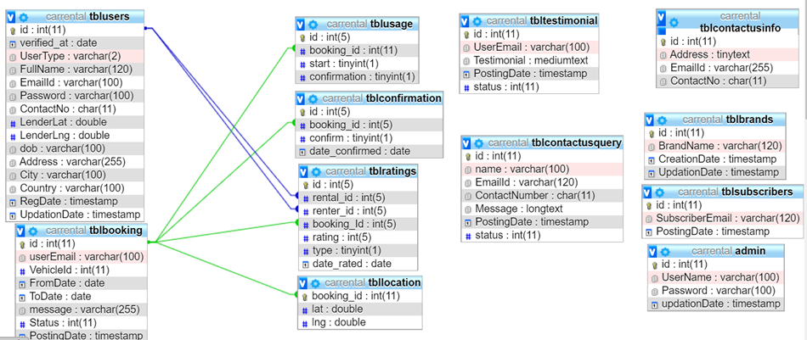

**CHAPTER 5**

**DATABASE DESIGN**

**Database Design:**

* From the analysis phase, a logical model of the system was created. And the following particular activity describes the proposed system’s data organization, storage and management. Which is to be managed by the DBMS a system responsible for storing, retrieving and protecting the data. These issues are important as they affect the consistency and quality of the data. The data is structured in files or tables that interact in various ways. Each table contains data about students, professors, users and subjects. According to Dennis, relational database is the most popular kind of database for application development today. And it is based on collections of tables with each table having a primary key, which is a field or fields whose values are unique for every row of the table and are used to identify each row or record. The tables are related to one another by placing the primary key from one table into the related table as a foreign key. Most relational database management systems (RDBMS) support referential integrity, or the idea of ensuring that values linking the tables together through the primary and foreign keys are valid and correctly synchronized.

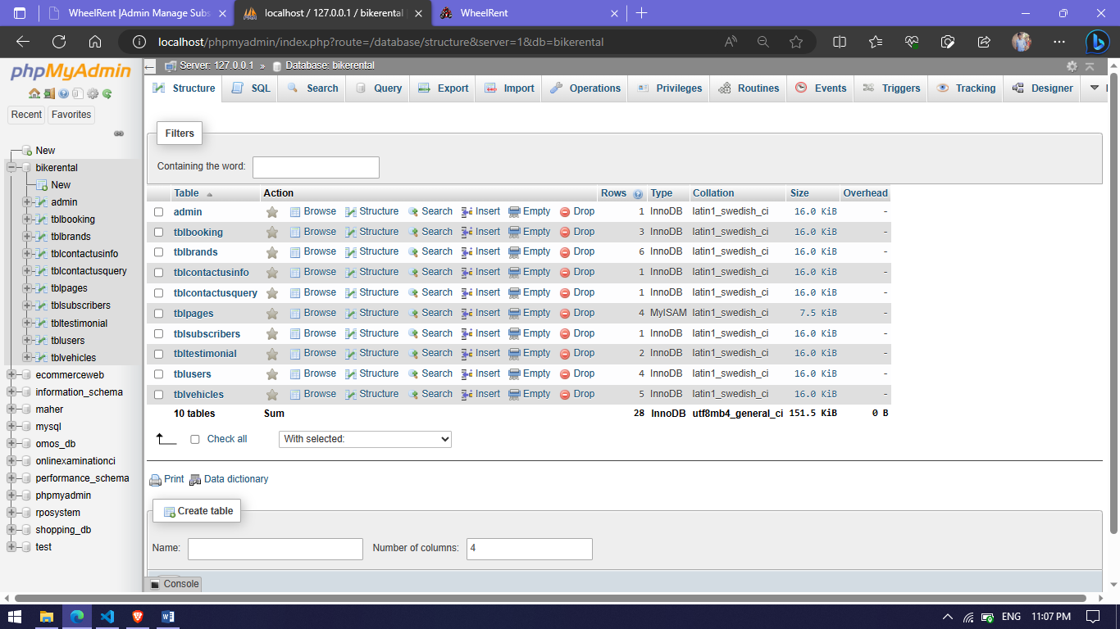

* **Sequence Diagram**

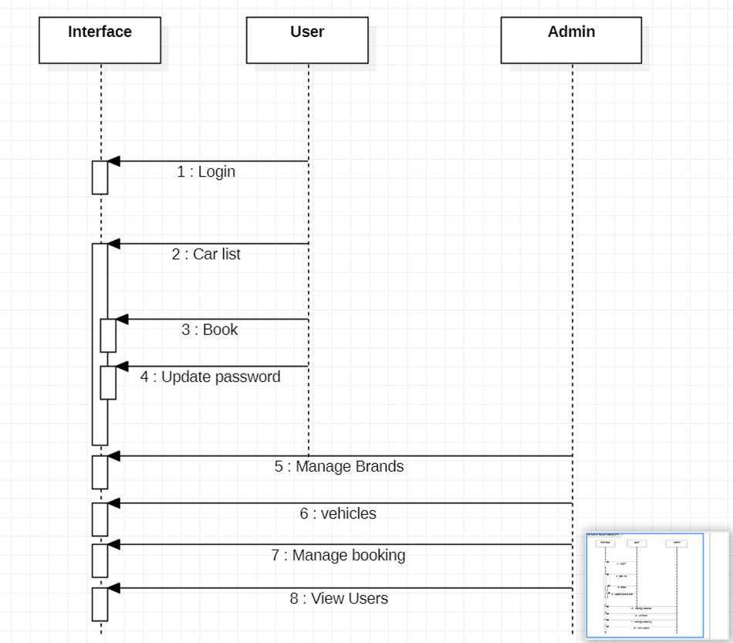

* **Flow Chart**

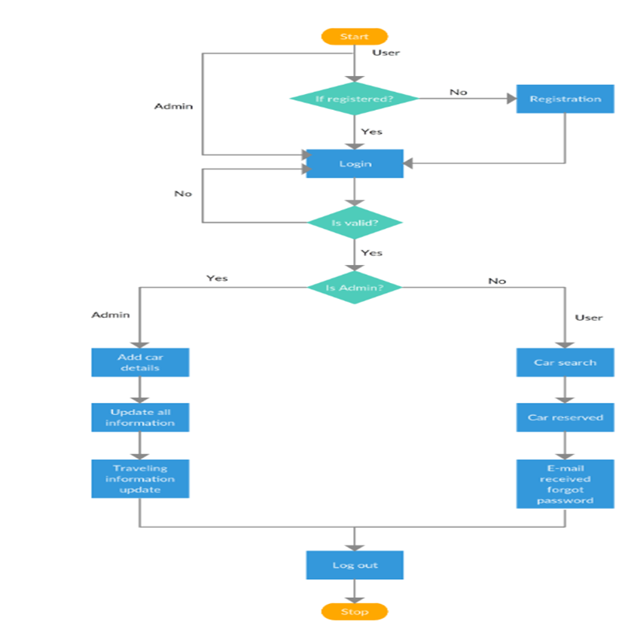

**CHAPTER 6**

**CODING**

**SAMPLE CODE**

**Index.php:**

<?php

session_start();

include('includes/config.php');

error_reporting(0);

?>

<!DOCTYPE HTML>

<html lang="en">

<head>

<meta http-equiv="Content-Type" content="text/html; charset=utf-8">

<meta http-equiv="X-UA-Compatible" content="IE=edge">

<meta name="viewport" content="width=device-width,initial-scale=1">

<meta name="keywords" content="">

<meta name="description" content="">

<title>WheelRent</title>

<!--Bootstrap -->

<link rel="stylesheet" href="assets/css/bootstrap.min.css" type="text/css">

<link rel="stylesheet" href="assets/css/styles.css" type="text/css">

<link rel="stylesheet" href="assets/css/owl.carousel.css" type="text/css">

<link rel="stylesheet" href="assets/css/owl.transitions.css" type="text/css">

<link href="assets/css/slick.css" rel="stylesheet">

<link href="assets/css/bootstrap-slider.min.css" rel="stylesheet">

<link href="assets/css/font-awesome.min.css" rel="stylesheet">

    <link rel="stylesheet" id="switcher-css" type="text/css" href="assets/switcher/css/switcher.css" media="all" />

    <link rel="alternate stylesheet" type="text/css" href="assets/switcher/css/red.css" title="red" media="all" data-default-color="true" />

    <link rel="alternate stylesheet" type="text/css" href="assets/switcher/css/orange.css" title="orange" media="all" />

    <link rel="alternate stylesheet" type="text/css" href="assets/switcher/css/blue.css" title="blue" media="all" />

    <link rel="alternate stylesheet" type="text/css" href="assets/switcher/css/pink.css" title="pink" media="all" />

    <link rel="alternate stylesheet" type="text/css" href="assets/switcher/css/green.css" title="green" media="all" />

    <link rel="alternate stylesheet" type="text/css" href="assets/switcher/css/purple.css" title="purple" media="all" />

<link rel="apple-touch-icon-precomposed" sizes="144x144" href="assets/images/favicon-icon/apple-touch-icon-144-precomposed.png">

<link rel="apple-touch-icon-precomposed" sizes="114x114" href="assets/images/favicon-icon/apple-touch-icon-114-precomposed.html">

<link rel="apple-touch-icon-precomposed" sizes="72x72" href="assets/images/favicon-icon/apple-touch-icon-72-precomposed.png">

<link rel="apple-touch-icon-precomposed" href="assets/images/favicon-icon/apple-touch-icon-57-precomposed.png">

<link rel="shortcut icon" href="assets/images/favicon-icon/24x24.png">

<link href="https://fonts.googleapis.com/css?family=Lato:300,400,700,900" rel="stylesheet">

</head>

<body>

<!-- Start Switcher -->

<?php include('includes/colorswitcher.php');?>

<!-- /Switcher -->

<!--Header-->

<?php include('includes/header.php');?>

<!-- /Header -->

<!-- Banners -->

<section id="banner" class="banner-section">

  <div class="container">

    <div class="div_zindex">

      <div class="row">

        <div class="col-md-5 col-md-push-7">

          <div class="banner_content">

            <h1>Find Your Perfect bike</h1>

            <p>We have collection of bikes for you to choose. </p>

            <a href="#" class="btn">Read More <span class="angle_arrow"><i class="fa fa-angle-right" aria-hidden="true"></i></span></a> </div>

        </div>

      </div>

    </div>

  </div>

</section>

<!-- /Banners -->

<!-- Resent Cat-->

<section class="section-padding gray-bg">

  <div class="container">

    <div class="section-header text-center">

      <h2>Find the Best <span>Bike For You</span></h2>

      <p>You will be able to fully enjoy your holiday and your ride! Any problems? Our passionate team will be happy to help you!! No waste of time during your holidays to find a rental point on the spot! No language barrier, thanks to our multilingual team! At the same price you would pay on the spot! We have best bikes with best deals</p>

    </div>

    <div class="row">

      <!-- Nav tabs -->

      <div class="recent-tab">

        <ul class="nav nav-tabs" role="tablist">

          <li role="presentation" class="active"><a href="#resentnewcar" role="tab" data-toggle="tab">New Bikes</a></li>

        </ul>

      </div>

      <!-- Recently Listed New Cars -->

      <div class="tab-content">

        <div role="tabpanel" class="tab-pane active" id="resentnewcar">

<?php $sql = "SELECT tblvehicles.VehiclesTitle,tblbrands.BrandName,tblvehicles.PricePerDay,tblvehicles.FuelType,tblvehicles.ModelYear,tblvehicles.id,tblvehicles.SeatingCapacity,tblvehicles.VehiclesOverview,tblvehicles.Vimage1 from tblvehicles join tblbrands on tblbrands.id=tblvehicles.VehiclesBrand";

$query = $dbh -> prepare($sql);

$query->execute();

$results=$query->fetchAll(PDO::FETCH_OBJ);

$cnt=1;

if($query->rowCount() > 0)

{

foreach($results as $result)

{

?>

<div class="col-list-3">

<div class="recent-car-list">

<div class="car-info-box"> <a href="vehical-details.php?vhid=<?php echo htmlentities($result->id);?>"><img src="admin/img/vehicleimages/<?php echo htmlentities($result->Vimage1);?>" class="img-responsive" alt="image"></a>

<ul>

<li><i class="fa fa-car" aria-hidden="true"></i><?php echo htmlentities($result->FuelType);?></li>

<li><i class="fa fa-calendar" aria-hidden="true"></i><?php echo htmlentities($result->ModelYear);?> Model</li>

<li><i class="fa fa-user" aria-hidden="true"></i><?php echo htmlentities($result->SeatingCapacity);?> seats</li>

</ul>

</div>

<div class="car-title-m">

<h6><a href="vehical-details.php?vhid=<?php echo htmlentities($result->id);?>"><?php echo htmlentities($result->BrandName);?> , <?php echo htmlentities($result->VehiclesTitle);?></a></h6>

<span class="price">₹<?php echo htmlentities($result->PricePerDay);?> /Day</span>

</div>

<div class="inventory_info_m">

<p><?php echo substr($result->VehiclesOverview,0,70);?></p>

</div>

</div>

</div>

<?php }}?>

      </div>

    </div>

  </div>

</section>

<!-- /Resent Cat -->

<!-- Fun Facts-->

<section class="fun-facts-section">

  <div class="container div_zindex">

    <div class="row">

      <div class="col-lg-3 col-xs-6 col-sm-3">

        <div class="fun-facts-m">

          <div class="cell">

            <h2><i class="fa fa-calendar" aria-hidden="true"></i>20+</h2>

            <p>Years In Business</p>

          </div>

        </div>

      </div>

      <div class="col-lg-3 col-xs-6 col-sm-3">

        <div class="fun-facts-m">

          <div class="cell">

            <h2><i class="fa fa-motorcycle " aria-hidden="true"></i>500+</h2>

            <p>New Bikes For Sale</p>

          </div>

        </div>

      </div>

      <div class="col-lg-3 col-xs-6 col-sm-3">

        <div class="fun-facts-m">

          <div class="cell">

            <h2><i class="fa fa-motorcycle " aria-hidden="true"></i>799+</h2>

            <p>Used Bikes For Sale</p>

          </div>

        </div>

      </div>

      <div class="col-lg-3 col-xs-6 col-sm-3">

        <div class="fun-facts-m">

          <div class="cell">

            <h2><i class="fa fa-user-circle-o" aria-hidden="true"></i>1950+</h2>

            <p>Satisfied Customers</p>

          </div>

        </div>

      </div>

    </div>

  </div>

  <!-- Dark Overlay-->

  <div class="dark-overlay"></div>

</section>

<!-- /Fun Facts-->

<!--Testimonial -->

<section class="section-padding testimonial-section parallex-bg">

  <div class="container div_zindex">

    <div class="section-header white-text text-center">

      <h2>Our Satisfied <span>Customer's Review</span></h2>

    </div>

    <div class="row">

      <div id="testimonial-slider">

<?php

$tid=1;

$sql = "SELECT tbltestimonial.Testimonial,tblusers.FullName from tbltestimonial join tblusers on tbltestimonial.UserEmail=tblusers.EmailId where tbltestimonial.status=:tid";

$query = $dbh -> prepare($sql);

$query->bindParam(':tid',$tid, PDO::PARAM_STR);

$query->execute();

$results=$query->fetchAll(PDO::FETCH_OBJ);

$cnt=1;

if($query->rowCount() > 0)

{

foreach($results as $result)

{  ?>

        <div class="testimonial-m">

          <div class="testimonial-img"> <img src="#" alt="" /> </div> <!-- change the image -->

          <div class="testimonial-content">

            <div class="testimonial-heading">

              <h5><?php echo htmlentities($result->FullName);?></h5>

            <p><?php echo htmlentities($result->Testimonial);?></p>

          </div>

        </div>

        </div>

        <?php }} ?>

      </div>

    </div>

  </div>

  <!-- Dark Overlay-->

  <div class="dark-overlay"></div>

</section>

<!-- /Testimonial-->

<!--Footer -->

<?php include('includes/footer.php');?>

<!-- /Footer-->

<!--Back to top-->

<div id="back-top" class="back-top"> <a href="#top"><i class="fa fa-angle-up" aria-hidden="true"></i> </a> </div>

<!--/Back to top-->

<!--Login-Form -->

<?php include('includes/login.php');?>

<!--/Login-Form -->

<!--Register-Form -->

<?php include('includes/registration.php');?>

<!--/Register-Form -->

<!--Forgot-password-Form -->

<?php include('includes/forgotpassword.php');?>

<!--/Forgot-password-Form -->

<!-- Scripts -->

<script src="assets/js/jquery.min.js"></script>

<script src="assets/js/bootstrap.min.js"></script>

<script src="assets/js/interface.js"></script>

<!--Switcher-->

<script src="assets/switcher/js/switcher.js"></script>

<!--bootstrap-slider-JS-->

<script src="assets/js/bootstrap-slider.min.js"></script>

<!--Slider-JS-->

<script src="assets/js/slick.min.js"></script>

<script src="assets/js/owl.carousel.min.js"></script>

</body>

</html>

**booking.php:**

<?php

session_start();

error_reporting(0);

include('includes/config.php');

if(strlen($_SESSION['login'])==0)

  {

header('location:index.php');

}

else{

?><!DOCTYPE HTML>

<html lang="en">

<head>

<meta http-equiv="Content-Type" content="text/html; charset=utf-8">

<meta http-equiv="X-UA-Compatible" content="IE=edge">

<meta name="viewport" content="width=device-width,initial-scale=1">

<meta name="keywords" content="">

<meta name="description" content="">

<title>WheelRent</title>

<!--Bootstrap -->

<link rel="stylesheet" href="assets/css/bootstrap.min.css" type="text/css">

<!--Custome Style -->

<link rel="stylesheet" href="assets/css/styles.css" type="text/css">

<!--OWL Carousel slider-->

<link rel="stylesheet" href="assets/css/owl.carousel.css" type="text/css">

<link rel="stylesheet" href="assets/css/owl.transitions.css" type="text/css">

<!--slick-slider -->

<link href="assets/css/slick.css" rel="stylesheet">

<!--bootstrap-slider -->

<link href="assets/css/bootstrap-slider.min.css" rel="stylesheet">

<!--FontAwesome Font Style -->

<link href="assets/css/font-awesome.min.css" rel="stylesheet">

<!-- SWITCHER -->

    <link rel="stylesheet" id="switcher-css" type="text/css" href="assets/switcher/css/switcher.css" media="all" />

    <link rel="alternate stylesheet" type="text/css" href="assets/switcher/css/red.css" title="red" media="all" data-default-color="true" />

    <link rel="alternate stylesheet" type="text/css" href="assets/switcher/css/orange.css" title="orange" media="all" />

    <link rel="alternate stylesheet" type="text/css" href="assets/switcher/css/blue.css" title="blue" media="all" />

    <link rel="alternate stylesheet" type="text/css" href="assets/switcher/css/pink.css" title="pink" media="all" />

    <link rel="alternate stylesheet" type="text/css" href="assets/switcher/css/green.css" title="green" media="all" />

    <link rel="alternate stylesheet" type="text/css" href="assets/switcher/css/purple.css" title="purple" media="all" />

<!-- Fav and touch icons -->

<link rel="apple-touch-icon-precomposed" sizes="144x144" href="assets/images/favicon-icon/apple-touch-icon-144-precomposed.png">

<link rel="apple-touch-icon-precomposed" sizes="114x114" href="assets/images/favicon-icon/apple-touch-icon-114-precomposed.html">

<link rel="apple-touch-icon-precomposed" sizes="72x72" href="assets/images/favicon-icon/apple-touch-icon-72-precomposed.png">

<link rel="apple-touch-icon-precomposed" href="assets/images/favicon-icon/apple-touch-icon-57-precomposed.png">

<link rel="shortcut icon" href="assets/images/favicon-icon/24x24.png">

<!-- Google-Font-->

<link href="https://fonts.googleapis.com/css?family=Lato:300,400,700,900" rel="stylesheet">

<!-- HTML5 Shim and Respond.js IE8 support of HTML5 elements and media queries -->

<!-- WARNING: Respond.js doesn't work if you view the page via file:// -->

<!--[if lt IE 9]>

        <script src="https://oss.maxcdn.com/libs/html5shiv/3.7.0/html5shiv.js"></script>

        <script src="https://oss.maxcdn.com/libs/respond.js/1.4.2/respond.min.js"></script>

<![endif]-->

</head>

<body>

<!-- Start Switcher -->

<?php include('includes/colorswitcher.php');?>

<!-- /Switcher -->

<!--Header-->

<?php include('includes/header.php');?>

<!--Page Header-->

<!-- /Header -->

<!--Page Header-->

<section class="page-header profile_page">

  <div class="container">

    <div class="page-header_wrap">

      <div class="page-heading">

        <h1>My Booking</h1>

      </div>

      <ul class="coustom-breadcrumb">

        <li><a href="#">Home</a></li>

        <li>My Booking</li>

      </ul>

    </div>

  </div>

  <!-- Dark Overlay-->

  <div class="dark-overlay"></div>

</section>

<!-- /Page Header-->

<?php

$useremail=$_SESSION['login'];

$sql = "SELECT * from tblusers where EmailId=:useremail";

$query = $dbh -> prepare($sql);

$query -> bindParam(':useremail',$useremail, PDO::PARAM_STR);

$query->execute();

$results=$query->fetchAll(PDO::FETCH_OBJ);

$cnt=1;

if($query->rowCount() > 0)

{

foreach($results as $result)

{ ?>

<section class="user_profile inner_pages">

  <div class="container">

    <div class="user_profile_info gray-bg padding_4x4_40">

      <div class="upload_user_logo"> <img src="assets/images/dealer-logo.jpg" alt="image">

      </div>

      <div class="dealer_info">

        <h5><?php echo htmlentities($result->FullName);?></h5>

        <p><?php echo htmlentities($result->Address);?><br>

          <?php echo htmlentities($result->City);?>&nbsp;<?php echo htmlentities($result->Country); }}?></p>

      </div>

    </div>

    <div class="row">

      <div class="col-md-3 col-sm-3">

       <?php include('includes/sidebar.php');?>

      <div class="col-md-6 col-sm-8">

        <div class="profile_wrap">

          <h5 class="uppercase underline">My Bookings </h5>

          <div class="my_vehicles_list">

            <ul class="vehicle_listing">

<?php

$useremail=$_SESSION['login'];

 $sql = "SELECT tblvehicles.Vimage1 as Vimage1,tblvehicles.VehiclesTitle,tblvehicles.id as vid,tblbrands.BrandName,tblbooking.FromDate,tblbooking.ToDate,tblbooking.message,tblbooking.Status  from tblbooking join tblvehicles on tblbooking.VehicleId=tblvehicles.id join tblbrands on tblbrands.id=tblvehicles.VehiclesBrand where tblbooking.userEmail=:useremail";

$query = $dbh -> prepare($sql);

$query-> bindParam(':useremail', $useremail, PDO::PARAM_STR);

$query->execute();

$results=$query->fetchAll(PDO::FETCH_OBJ);

$cnt=1;

if($query->rowCount() > 0)

{

foreach($results as $result)

{  ?>

<li>

                <div class="vehicle_img"> <a href="vehical-details.php?vhid=<?php echo htmlentities($result->vid);?>""><img src="admin/img/vehicleimages/<?php echo htmlentities($result->Vimage1);?>" alt="image"></a> </div>

                <div class="vehicle_title">

                  <h6><a href="vehical-details.php?vhid=<?php echo htmlentities($result->vid);?>""> <?php echo htmlentities($result->BrandName);?> , <?php echo htmlentities($result->VehiclesTitle);?></a></h6>

                  <p><b>From Date:</b> <?php echo htmlentities($result->FromDate);?><br /> <b>To Date:</b> <?php echo htmlentities($result->ToDate);?></p>

                </div>

                <?php if($result->Status==1)

                { ?>

                <div class="vehicle_status"> <a href="#" class="btn outline btn-xs active-btn">Confirmed</a>

                           <div class="clearfix"></div>

        </div>

              <?php } else if($result->Status==2) { ?>

 <div class="vehicle_status"> <a href="#" class="btn outline btn-xs">Cancelled</a>

            <div class="clearfix"></div>

        </div>

                <?php } else { ?>

 <div class="vehicle_status"> <a href="#" class="btn outline btn-xs">Not Confirm yet</a>

            <div class="clearfix"></div>

        </div>

                <?php } ?>

       <div style="float: left"><p><b>Message:</b> <?php echo htmlentities($result->message);?> </p></div>

              </li>

              <?php }} ?>

            </ul>

          </div>

        </div>

      </div>

    </div>

  </div>

</section>

<!--/my-vehicles-->

<?php include('includes/footer.php');?>

<!-- Scripts -->

<script src="assets/js/jquery.min.js"></script>

<script src="assets/js/bootstrap.min.js"></script>

<script src="assets/js/interface.js"></script>

<!--Switcher-->

<script src="assets/switcher/js/switcher.js"></script>

<!--bootstrap-slider-JS-->

<script src="assets/js/bootstrap-slider.min.js"></script>

<!--Slider-JS-->

<script src="assets/js/slick.min.js"></script>

<script src="assets/js/owl.carousel.min.js"></script>

</body>

</html>

<?php } ?>

**CHAPTER 7**

**TESTING**

**TESTING**

**Software Testing:**

Software Testing is a method to check whether the actual software product matches expected requirements and to ensure that software product is[Defect](https://www.guru99.com/defect-management-process.html)free. It involves execution of software/system components using manual or automated tools to evaluate one or more properties of interest. The purpose of software testing is to identify errors, gaps or missing requirements in contrast to actual requirements.

**Software Testing is Important** because if there are any bugs or errors in the software, it can be identified early and can be solved before delivery of the software product. Properly tested software product ensures reliability, security and high performance which further results in time saving, cost effectiveness and customer satisfaction.

**Alpha Testing:**

Alpha testing is a type of testing that is done on an application towards the end of a development process when the product is almost in a usable state. This type of testing does not involve functional testing on the application. Instead, it is a user testing on the application in order to understand the user behavior and experience on the application. Normally this test is performed by test engineers, employees and sometimes friends / family members with the aim of trying to emulate around 80% of the customers. While these users test and give their feedback, the development team observes the behavior to check for design issues in the application. Alpha testing is mainly conducted to unveil bugs that might arise due to abrupt errors created by the users, validate the quality state of the software in minimal time and finally propound a build that procures the specifications required. Once this test is executed properly, the software is ready for the next stage, i.e., the beta test. Alpha testing has two phases.

**Black Box Testing:**

Black box testing refers to any type of software test that examines an application without knowledge of the internal design, structure, or implementation of the software project. Black box testing can be performed at multiple levels, including unit testing, integration testing, system testing, or acceptance testing.

1. **Unit Testing: -**

* Unit testing is essentially for the verification of the code produced during the coding phase and the goal is test the internal logic of the module/program. In the Generic code project, the unit testing is done during coding phase of data entry forms whether the functions are working properly or not. In this phase all the drivers are tested they are rightly connected or not.

1. **Integration Testing: -**

* All the tested modules are combined into sub systems, which are then tested. The goal is to see if the modules are properly integrated, and the emphasis being on the testing interfaces between the modules. In the generic code integration testing is done mainly on table creation module and insertion module.

**VALIDATION TESTING**

* This testing concentrates on confirming that the software is error-free in all respects. All the specified validations are verified and the software is subjected to hard-core testing. It also aims at determining the degree of deviation that exists in the software designed from the specification; they are listed out and are corrected.

**SYSTEM TESTING**

* This testing is a series of different tests whose primary is to fully exercise the computer-based system.
* This involves, implementing the system in a simulated production environment and testing it.

**White Box Testing:**

**White Box Testing** is software testing technique in which internal structure, design and coding of software are tested to verify flow of input-output and to improve design, usability and security. In white box testing, code is visible to testers so it is also called Clear box testing, open box testing, transparent box testing, Code-based testing and Glass box testing.

**Beta Testing:**

Beta testing is one of the final steps in your [software development lifecycle](https://www.applause.com/blog/finding-holistic-agile-testing-solutions) (SDLC) before a product goes live. Also referred to as user testing or customer validation, beta testing aims to ensure that end users are satisfied with a software product before you make it generally available (GA). While beta tests want to catch any software bugs and errors that have snuck through the testing process, it is more about understanding and improving the product’s full end user experience before it becomes GA. That means thoroughly investigating the experience flow and understanding any pain points that will hinder enjoyment of the experience for your end user.

**Positive Test Cases:**

* The positive flow of the functionality must be considered
* Valid inputs must be used for testing
* Must have the positive perception to verify whether the requirements are justified.

**Negative Test Cases:**

* Must have negative perception
* Invalid inputs must be used for test.

**Feasibility Study:**

* The next step in analysis is to verify the feasibility of the proposed system. “All projects are feasible given unlimited resources and infinite time “. But in reality, both resources and time are sBikece. Project should confirm to time bounce and should be optimal in their consumption of resources. This place a constant is approval of any project.
* Feasibility has applied to the following areas:

Technical feasibility

Operational feasibility

Economic feasibility

**TECHNICAL FEASIBILITY:**

* To determine whether the proposed system is technically feasible, we should take into consideration the technical issues involved behind the system.

**OPERATIONAL FEASIBILITY:**

* To determine the operational feasibility of the system we should take into consideration the awareness level of the users. This system is operational feasible since the users are familiar with the technologies and hence there is no need to gear up the personnel to use system. Also, the system is very friendly and to use.

**ECONOMIC FEASIBILITY:**

To decide whether a project is economically feasible, we have to consider various factors as:

* Cost benefit analysis
* Long-term returns
* Maintenance costs

**CHAPTER 8**

**SCREENSHOTS**

**Login Page:**

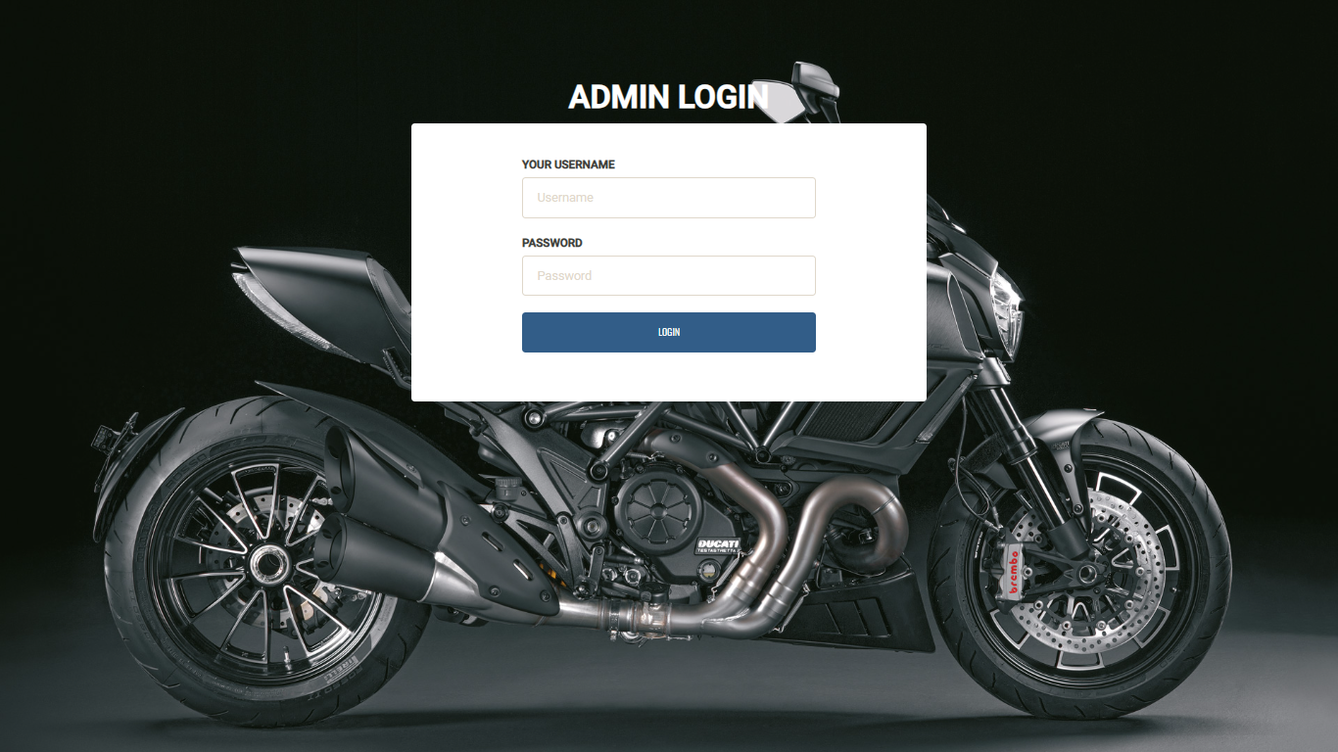

**Admin Dashboard:**

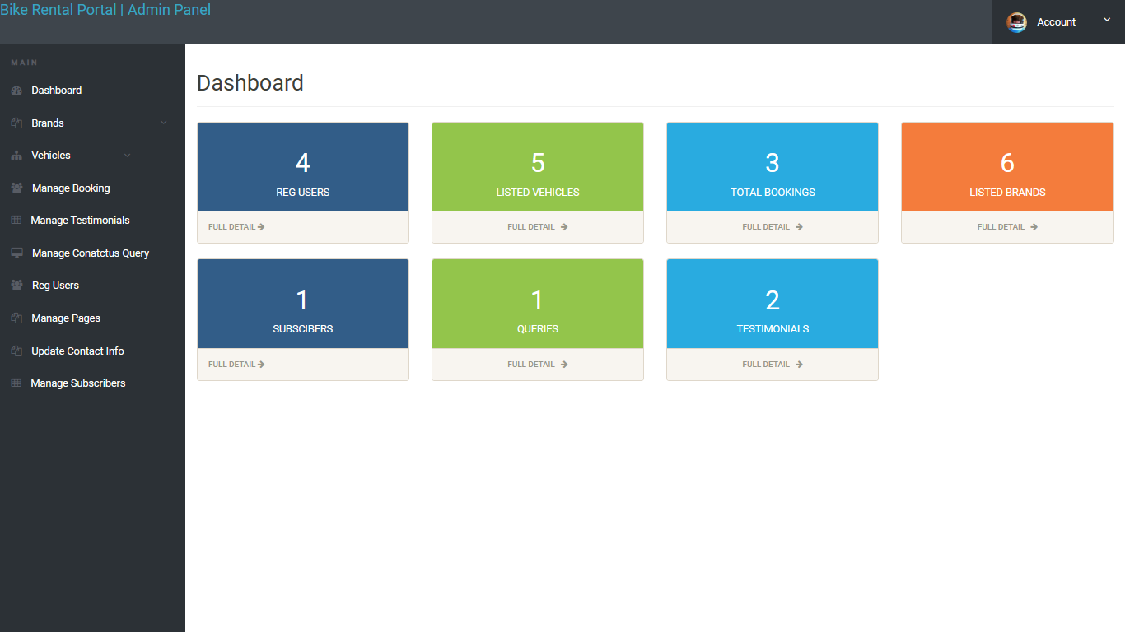

**Home Page:**

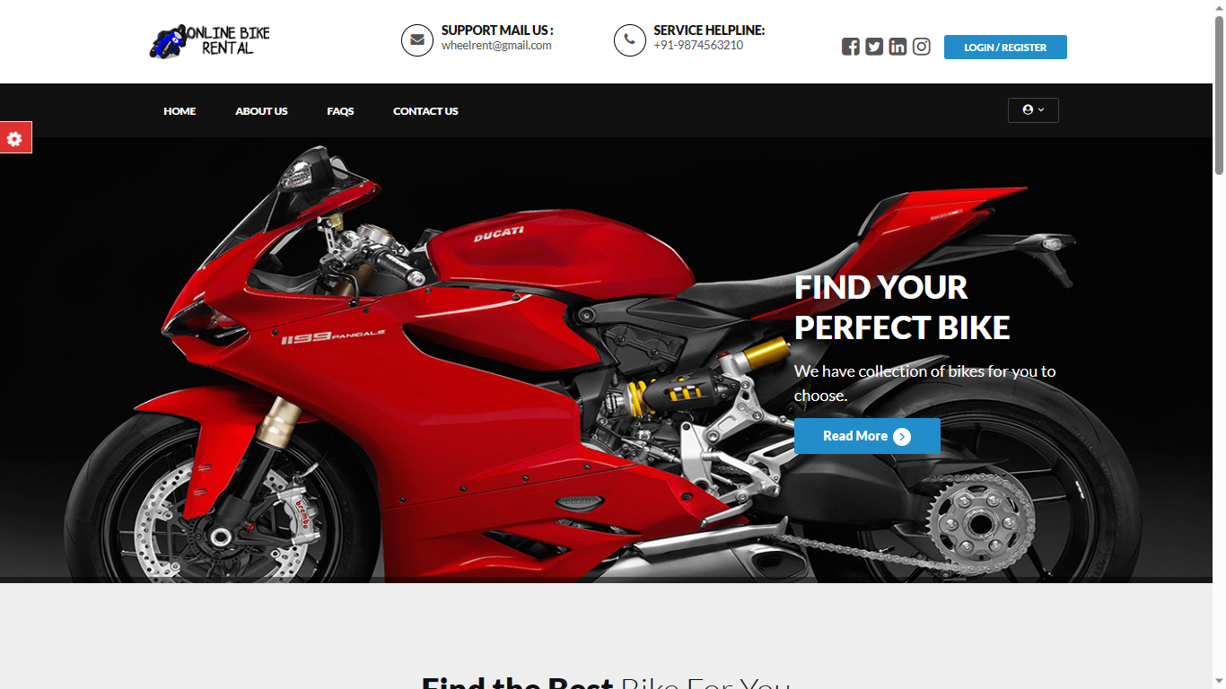

**User Profile Page:**

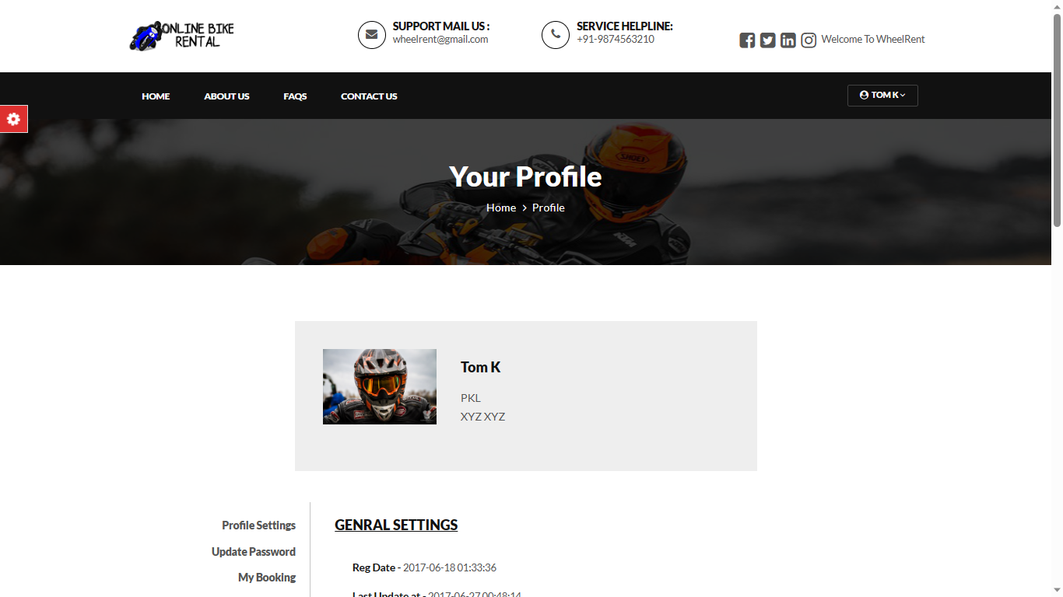

**Brands Manage:**

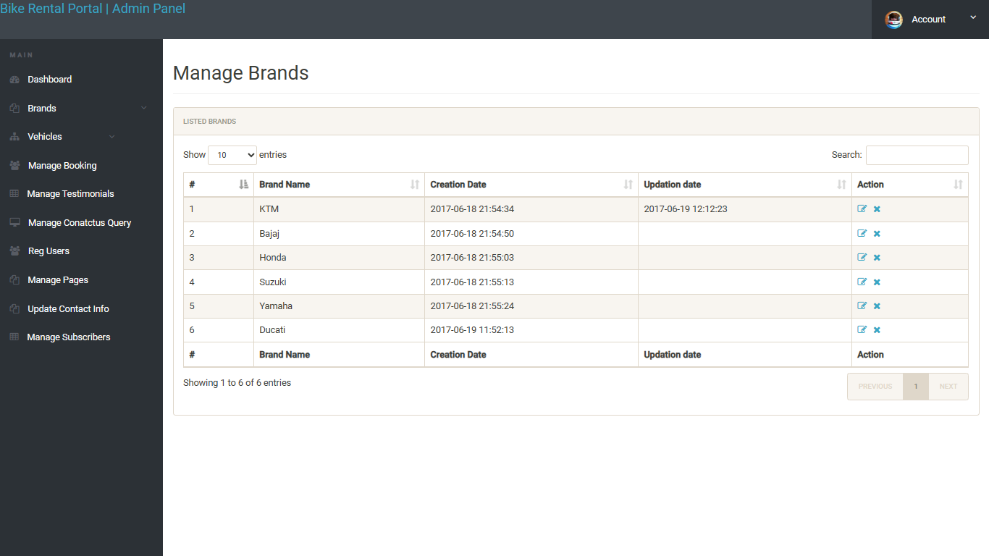

**Vehicles Manage:**

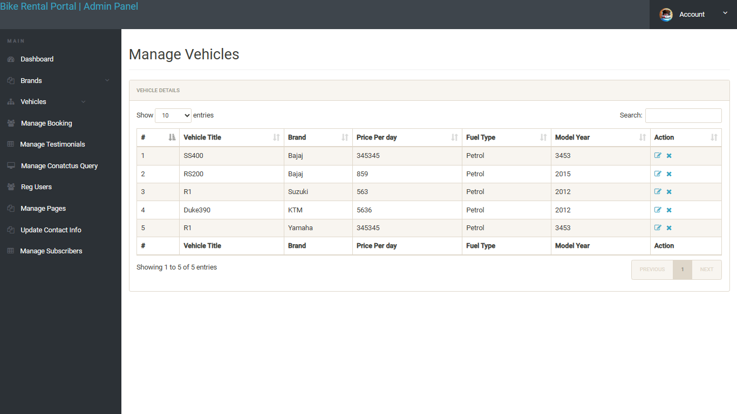

**CHAPTER 9**

**ANALYSIS AND DESIGN**

**Use Case Diagram:**

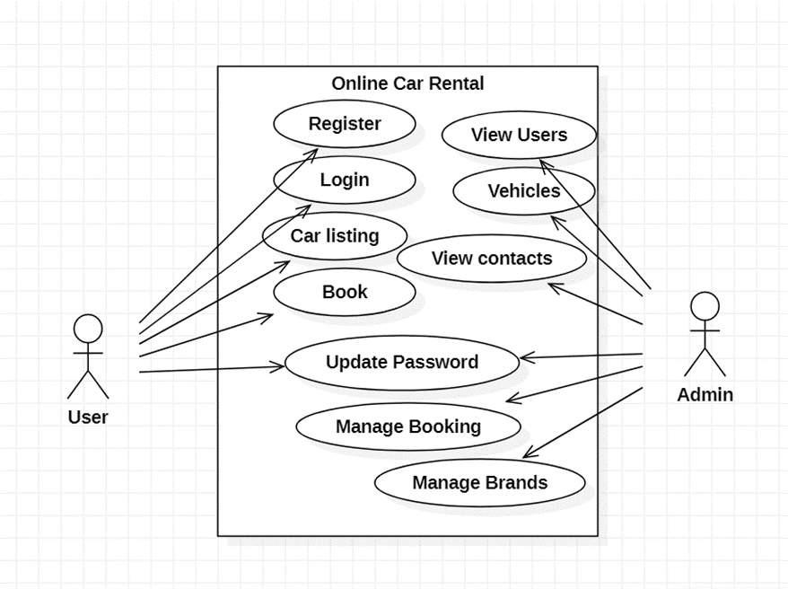

**Data Flow Analysis:**

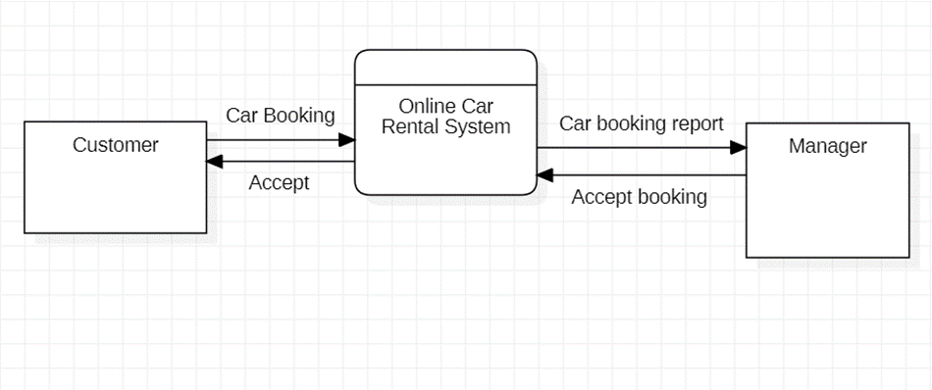

**CHAPTER 10**

**CONCLUSION**

**CONCLUSION**

So, the final conclusion we make here is that our new project based website is much better and easy to use than the traditional project website. Almost all problems that we have discussed in the problem definition section are resolved by the help of this application. So, the launch of this application would create many opportunities for those who are frequently involved in conducting such script analyzing processes for different purposes.

**CHAPTER 11**

**FUTURE ENHANCEENT**

**FUTURE ENHANCEMENT**

* Presently, the system provides a user-friendly interface though we can allow customers in future to filter them based on specific criteria such as location, car type, and rental duration, and make bookings accordingly
* We can implement secure payment gateways to facilitate online transactions, ensuring a seamless and trustworthy experience for users.
* The system provides a user-friendly interface that allows customers to browse through a wide range of available cars, filter them based on specific criteria such as location, car type, and rental duration, and make bookings accordingly. It incorporates secure payment gateways to facilitate online transactions, ensuring a seamless and trustworthy experience for users.

**CHAPTER 12**

**BIBLIOGRAPHY**

**BIBLIOGRAPHY**

**Programming languages:**

• <https://www.w3schools.com>

• <https://www.javapoint.com>

• <https://www.youtube.com>

• <https://www.wikipedia.com>

• [https://getbootstrap.com](https://getbootstrap.com/)

**Software:**

* [www.apachefriends.org](https://www.apachefriends.org/)
* [visualstudio.com](https://code.visualstudio.com/)

**References:**

# Deepankar Vishwas Kotwal, Shubham Rajendra Bhadke, Aishwarya Sanjay Gunjal, Puspendu Biswas, “ONLINE EXAMINATION SYSTEM”, International Research Journal of Engineering and Technology (IRJET), Volume: 03 Issue: 01 | Jan-2016

# Zhao Qiao-fang & Li Yong-fei, “Research and Development of Online Examination System” Published by Atlantis Press, Paris, France

# Scott Tilley & Harry J. Rosenblatt, Systems Analysis and Design (Shelly Cashman Series) 11th Edition, ISBN-13: 978-1305494602

# Nicholas A. Omoregbe, Ambrose A. Azeta, Adewole Adewumi, Ajayi O. Oluwafunmilola, “IMPLEMENTING AN ONLINE EXAMINATION SYSTEM”, Covenant University (NIGERIA)